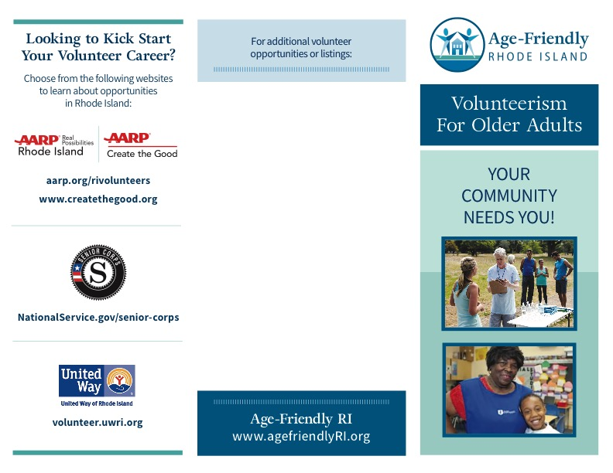

Double-click on this text box to add content.

This is a regular text box. You can type into this and insert a logo.

Do not try to type outside this box. A PDF of the brochure design was placed behind this text box.

Once you customize this area, you can save the file as a PDF (Save As > Name it > choose “PDF” instead of “docx”).

